HYDRATION BEHAVIOR OF PORTLAND AND COMPOSITE CEMENTS UNDER SEMI-ADIABATIC CONDITIONS

Abdur Nur Tushar¹ and Zisan Zia¹
Supervised by: Prof. Dr. Raquib Ahsan²
¹B.Sc. Graduate (2026), Dept. of Civil Engineering, BUET, Dhaka-1000, Bangladesh
²Professor, Dept. of Civil Engineering, BUET, Dhaka-1000, Bangladesh
Corresponding author: raquibahsan@ce.buet.ac.bd
ABSTRACT
Heat generated during cement hydration is a critical factor influencing temperature rise and thermal cracking risk in mass concrete. This study investigates four commercially available BDS EN 197-1:2003-compliant cements — CEM I 52.5N, CEM II A-M 42.5N, CEM II A-M 42.5R, and CEM II B-M 42.5N — under semi-adiabatic and sealed conditions. X-ray diffraction (XRD) on a PANalytical EMPYREAN diffractometer identified major clinker phases (C₃S, C₂S, C₃A, C₄AF). A calibrated bench-top semi-adiabatic calorimeter recorded temperature–time data that were processed in MATLAB to compute specific heat generation rate and cumulative heat release. A two-component Gaussian model (Gauss-2) resolved the overlapping aluminate (C₃A) and silicate (C₃S) hydration peaks, and sixth-order polynomial functions fitted cumulative heat curves (R² > 0.999) for use in finite element thermal simulations. Predictions from the NIST Virtual Cement and Concrete Testing Laboratory (VCCTL) validated experimental trends. CEM I 52.5N exhibited the highest cumulative heat (~467 J/g, adiabatic ΔT > 40°C), CEM II A-M 42.5R approached Portland behavior (~433 J/g) owing to its finer grinding, CEM II A-M 42.5N showed intermediate heat (~284 J/g), and CEM II B-M 42.5N released the least heat (~255 J/g), making it most suitable for thermally sensitive mass concrete. VCCTL confirmed the heat ranking within 11–37% deviation. The developed hydration models provide ready-to-use input parameters for thermal analysis and cement selection in mass concrete construction in Bangladesh.
Keywords: heat of hydration; semi-adiabatic calorimetry; XRD; Gaussian modeling; VCCTL; mass concrete; thermal cracking; Bangladesh.
1. INTRODUCTION
Cement hydration is exothermic: clinker minerals (C₃S, C₂S, C₃A, C₄AF) react with water and release heat that accumulates within concrete, particularly in mass elements such as raft foundations, bridge footings, dams, and thick retaining walls. When the hot concrete core cools faster at the surface, thermal gradients develop and can exceed the tensile capacity of young concrete, causing early-age thermal cracking that degrades durability and serviceability (Klemczak and Batog, 2016). ACI 207R recommends limiting the core-to-surface temperature differential to 20°C to minimize this risk.
Ordinary Portland cement (CEM I) exhibits high, rapid heat release due to its elevated clinker content. Composite cements (CEM II) reduce cumulative heat through partial clinker replacement by supplementary cementitious materials (SCMs) including limestone, fly ash, or slag (Lothenbach et al., 2011). However, the effect of strength class — specifically normal-strength (N) versus rapid-hardening (R) — on hydration heat is underreported for commercially produced composite cements. Most published studies focus on North American or European cements; hydration heat data for BDS EN 197-1-compliant Bangladeshi cements are scarce, limiting the ability of local engineers to design effective thermal control strategies for mass concrete construction.
This study addresses these gaps through an integrated experimental–analytical–computational framework applied to four commonly used Bangladeshi cements, representing the first undergraduate-level study at BUET combining semi-adiabatic calorimetry, XRD mineralogical characterization, MATLAB Gaussian and polynomial modeling, and NIST VCCTL validation for local cement types.
2. MATERIALS AND METHODOLOGY
2.1 Cement Samples and Sample Identification
Four commercially available cements conforming to BDS EN 197-1:2003 were selected (Table 1). Samples were stored in airtight containers after collection to prevent pre-hydration, carbonation, and moisture absorption prior to testing. Cement pastes were prepared at w/c = 0.40.

ID | Cement Type | Category | Expected Thermal Behavior
C1 | CEM II B-M 42.5N | High-blend composite | Lowest heat; slowest kinetics — best for mass concrete
C2 | CEM II A-M 42.5N | Moderate-blend composite | Intermediate heat; clinker diluted by limestone and SCMs
C3 | CEM II A-M 42.5R | Rapid-hardening composite | Accelerated early-age heat from finer grinding and higher C₃S reactivity
C4 | CEM I 52.5N | Ordinary Portland cement | Highest heat; fastest kinetics — greatest thermal cracking risk
Table 1. Cement sample identification and expected thermal behavior

2.2 XRD Mineralogical Characterization
X-ray diffraction analysis was conducted using a PANalytical EMPYREAN diffractometer (Cu Kα, λ = 1.5406 Å; scan 6°–90° 2θ; step 0.026°; 7.14 s/step; 40 mA, 45 kV; 25°C). Phase identification and semi-quantitative estimation were performed in HighScore Plus using the ICDD PDF-4+ database. Phase weight percentages were computed by the Reference Intensity Ratio (RIR) method: Phase_i (%) = (Scale_i / Σ Scale_j) × 100.
2.3 Semi-Adiabatic Calorimetry and Heat Calculation
A custom bench-top semi-adiabatic calorimeter recorded sample temperature Tₛ(t) and ambient temperature T_amb(t) at 60-second intervals. Electrical heating calibration (P = 500 W, ΔT = 40.3 K, τ = 248 s) yielded system heat capacity C = 3076.9 J/K (insulator contribution: Cᵢₙₛ = 1386.6 J/K). A cooling-curve experiment determined the heat-loss coefficient Kₗ = 2.13 J/min/K. The energy balance and specific heat generation rate are:
q_reaction(t) = Cₐ(t)·(dT/dt) + Kₗ·[Tₛ(t) − T_amb(t)] (1)
qᵍ(t) = q_reaction(t) / mᶜ ; Q(t) = ∫₀ᵗ qᵍ(t)dt [Simpson's 1/3 Rule] (2)
The time-varying heat capacity Cₐ(t) = 1160.67 × (1.5 − 0.5r) uses the degree of hydration r(t) = Q(t)/Q_max, following De Schutter and Taerwe (1995).
2.4 MATLAB Two-Component Gaussian and Polynomial Modeling
Temperature data were preprocessed (5-min interpolation, smoothing, t = 0 alignment) in MATLAB. The Gauss-2 model separately captures the early C₃A aluminate peak (G₁) and the dominant C₃S silicate peak (G₂):
q(t) = A₁ exp[−((t−μ₁)/σ₁)²] + A₂ exp[−((t−μ₂)/σ₂)²] (3)
Sixth-order polynomial functions (Poly-6) were fitted to cumulative heat curves, yielding smooth, analytically integrable analytical expressions (R² > 0.999) for finite element thermal simulation input.
2.5 VCCTL Numerical Validation
NIST Virtual Cement and Concrete Testing Laboratory (VCCTL) simulations used XRD-derived clinker phase proportions as primary inputs (w/c = 0.40; isothermal 20–25°C) to predict degree of hydration (DOH) and cumulative heat release. Experimental and simulated values were compared at 6, 12, and 19 h using relative percentage deviation: PD (%) = [(Q_VCCTL − Q_Exp) / Q_Exp] × 100.
3. RESULTS AND DISCUSSION
3.1 XRD Phase Composition
Semi-quantitative XRD phase compositions are summarized in Table 2. Alite (C₃S-related calcium silicate) is the primary reactive phase in all samples. CEM I 52.5N carries the highest combined silicate content (alite + belite + Ca-Mg-Al silicate ≈ 87.2%), explaining its dominant heat response. CEM II composites show progressively higher CaCO₃ fractions (38–55%) that dilute clinker and reduce total reactive phase per gram of cement. CEM II A-M 42.5R presents a notable aluminate phase (~7.7%) alongside belite (~16.9%), contributing to its accelerated early-age reactivity despite a substantial carbonate filler content.

Phase / Compound | C1: CEM II B-M 42.5N | C2: CEM II A-M 42.5N | C3: CEM II A-M 42.5R | C4: CEM I 52.5N
Alite / C₃S-related silicate (%) | 45.1 | 41.5 | 33.8 | 28.5
Belite / C₂S-related silicate (%) | 19.6* | — | 16.9 | 26.7
Aluminate-related (C₃A-type) (%) | 6.0 | — | 7.7 | 12.8
Ca-Mg-Al silicate / slag-type (%) | — | — | — | 32.1
Calcium carbonate CaCO₃ (%) | 43.9 | 54.8 | 38.0 | —
Quartz SiO₂ (%) | 5.0 | 3.7 | 3.6 | —
Fe-Mg carbonate (%) | — | 6.0 | — | —
Table 2. Semi-quantitative XRD phase composition of cement samples (* reported as additional Ca silicate / C₃S + C₂S overlap for C1)

3.2 Semi-Adiabatic Heat Generation Rate and Gaussian Fitting
Figure 1 shows the experimentally derived specific heat generation rate q^g(t) for each cement sample. All four cements display the characteristic two-stage hydration profile: an initial broad aluminate-associated peak (G₁) at early times, followed by the dominant silicate peak (G₂). CEM I 52.5N produces the tallest and earliest G₂ peak (≈3.3 J/min·g near t ≈ 290–340 min), consistent with its high reactive silicate content and absence of clinker dilution. The sharp early spike in CEM II A-M 42.5R (reaching up to ~8 J/min·g in the raw experimental data) is attributed to the rapid early aluminate reaction enhanced by the finer particle surface area of the R-class cement, though the Gauss-2 fitting smooths this to a representative G₁ amplitude of ~0.30–0.40 J/min·g as shown in Figure 2.

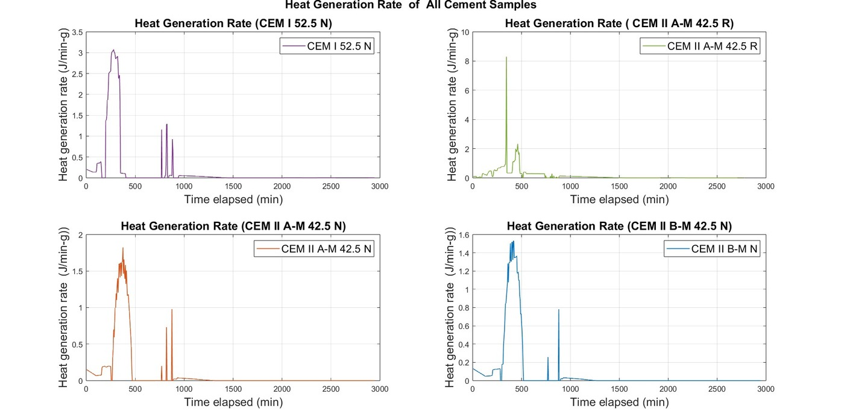
Figure 1. Experimental heat generation rate q^g(t) for all four cement samples (semi-adiabatic calorimetry, w/c = 0.40)

Figure 2 presents the Gauss-2 fitted heat generation rate curves for all four cements plotted on a common axis for direct comparison. The systematic retardation and attenuation of the G₂ silicate peak from CEM I 52.5N (G₂ peak ≈ 3.3 J/g at ~290 min) through CEM II A-M 42.5R (~1.1–1.2 J/g), CEM II A-M 42.5N (~1.7 J/g at ~440 min), to CEM II B-M 42.5N (~1.55 J/g at ~450–510 min) directly reflects the progressive reduction in reactive alite content as clinker dilution increases. Notably, the CEM II A-M 42.5R curve falls closer to CEM I 52.5N in peak timing (~310–370 min) than to normal-strength CEM II A-M 42.5N, confirming that the rapid-hardening classification substantially elevates early-age heat response.

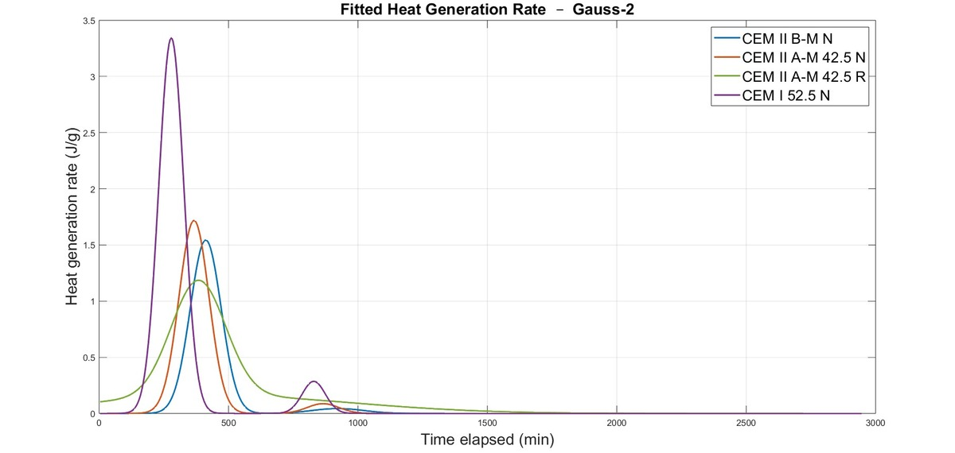
Figure 2. Two-component Gaussian (Gauss-2) fitted heat generation rate for all four cements plotted on a common axis

3.3 Cumulative Heat Release
Figure 3 presents both the experimental (left panel) and Gauss-2 fitted (right panel) cumulative heat release curves. Table 3 summarizes Gaussian model parameters and terminal values. CEM I 52.5N attains ~467 J/g — the highest among the tested cements. CEM II A-M 42.5R reaches ~433 J/g, only 7% below Portland cement despite containing moderate mineral additions; its rapid-hardening classification, achieved primarily through finer grinding (higher Blaine surface area), drives clinker reactivity to near-Portland levels. CEM II A-M 42.5N and CEM II B-M 42.5N release ~284 J/g and ~255 J/g respectively, reflecting their greater clinker dilution by supplementary materials. The Gauss-2 fit accurately reproduces the terminal values and plateau shape of all four cements.

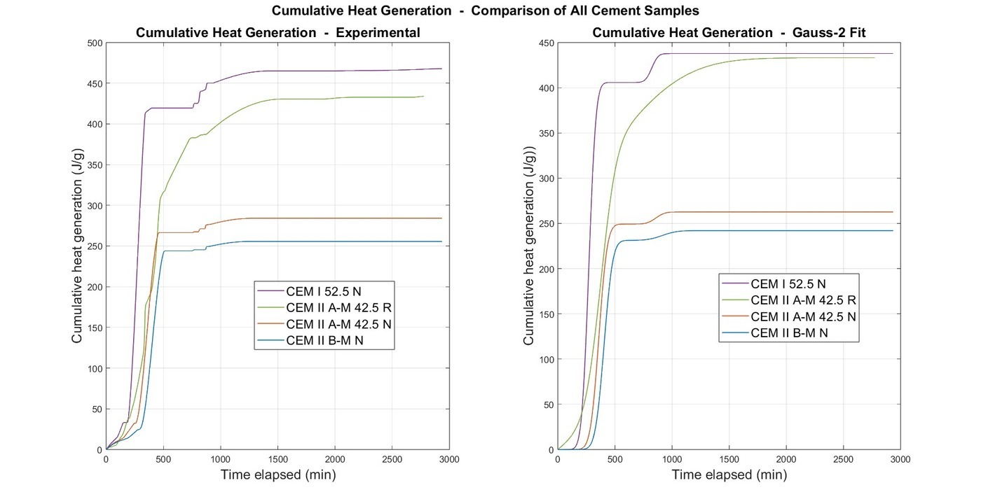
Figure 3. Cumulative heat generation: experimental (left) and Gauss-2 fitted (right) for all four cements

Parameter | CEM I 52.5N | CEM II A-M 42.5N | CEM II A-M 42.5R | CEM II B-M 42.5N
G₁ Amplitude A₁ (J/min·g) | 0.40–0.45 | 0.15–0.20 | 0.30–0.40 | 0.12–0.16
G₁ Peak Time μ₁ (min) | 220–260 | 280–320 | 230–270 | 320–360
G₂ Amplitude A₂ (J/min·g) | 2.8–3.3 | 1.5–2.0 | 2.2–2.6 | 1.3–1.6
G₂ Peak Time μ₂ (min) | 280–340 | 400–460 | 310–370 | 450–510
Terminal Cumulative Heat (J/g) | ~467 | ~284 | ~433 | ~255
Est. Adiabatic ΔT (°C) | >40–45 | 25–28 | 32–38 | 22–25
Table 3. Gauss-2 model parameters and cumulative heat release for all four cement types

3.4 VCCTL Validation
Figures 4 and 5 show the VCCTL-simulated degree of hydration (DOH) and cumulative heat release for all four cements under isothermal conditions. The simulated DOH and heat release rankings fully confirm the experimental findings. Table 4 quantifies the deviation between VCCTL predictions at 19 h and the experimental terminal values.

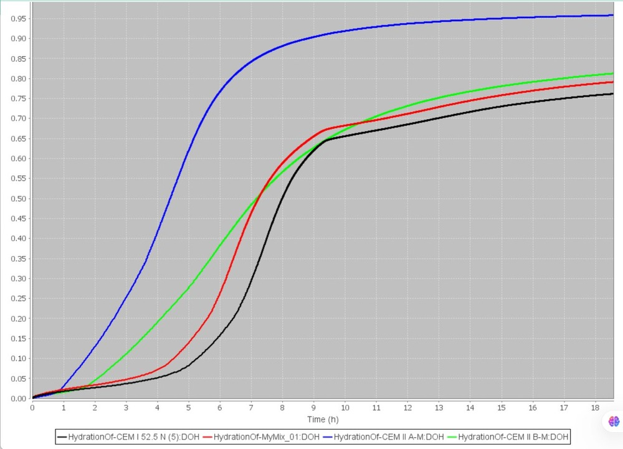  Figure 4. VCCTL-simulated degree of hydration vs. time for all four cements (isothermal, w/c = 0.40) |  | 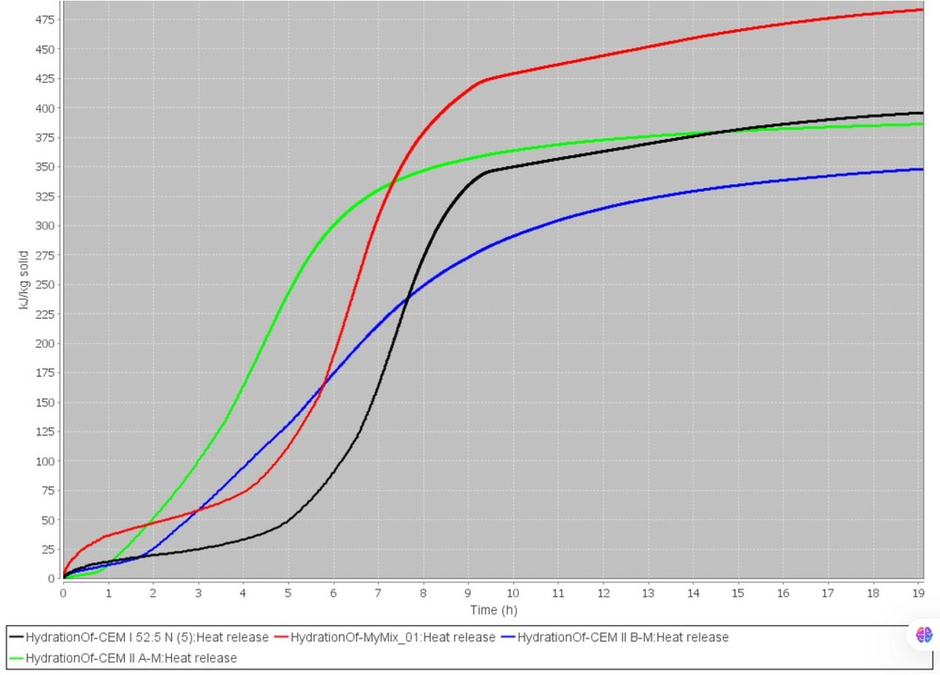  Figure 5. VCCTL-simulated cumulative heat release vs. time for all four cements (isothermal, w/c = 0.40)

The VCCTL DOH plot (Fig. 4) shows CEM II A-M 42.5N reaching the highest DOH (≈0.95 at 19 h) under isothermal conditions, while CEM I 52.5N exhibits the characteristic sigmoidal profile reaching ≈0.765 at 19 h. The heat release plot (Fig. 5) shows CEM II A-M 42.5R generating the most heat under isothermal conditions (≈480 kJ/kg), followed by CEM I 52.5N (≈400 kJ/kg), CEM II A-M 42.5N (≈390 kJ/kg), and CEM II B-M 42.5N (≈348 kJ/kg). The isothermal VCCTL ranking differs slightly from the semi-adiabatic experimental ranking (CEM I > CEM II A-M 42.5R for terminal heat) because VCCTL reaches the near-ultimate DOH within 19 h for all samples, while the experimental test captures the actual truncated heat evolution under heat-loss-corrected semi-adiabatic conditions.

Cement | Exp. Q (J/g) | VCCTL Q at 19 h (kJ/kg) | Rel. Dev. (%) | Primary Cause of Deviation
CEM I 52.5N | ≈467 | ≈400 | −14.3 | Semi-adiabatic captures the full early peak within the monitoring window
CEM II A-M 42.5N | ≈284 | ≈390 | +37.3 | Isothermal DOH ≈ 0.95; slow late-age heat under-captured by truncated semi-adiabatic test
CEM II A-M 42.5R | ≈433 | ≈480 | +10.9 | Higher Blaine area; isothermal ultimate heat slightly exceeds the truncated experimental value
CEM II B-M 42.5N | ≈255 | ≈348 | +36.5 | Low clinker; isothermal conditions accelerate slow blended hydration beyond the test window
Table 4. Experimental vs. VCCTL cumulative heat at 19 h with relative deviation

The agreement is closest for the high-clinker, high-reactivity cements (11–14% deviation) and largest for the slow blended cements (~37%), consistent with VCCTL's isothermal basis versus the heat-loss-corrected, truncated semi-adiabatic experiment. The overall experimental uncertainty is ±3% from calorimeter calibration (C = 3076.9 J/K; Kₗ = 2.13 J/min/K). The semi-quantitative nature of XRD-derived VCCTL inputs contributes additional variability.
3.5 Thermal Cracking Risk Assessment
Using the estimated adiabatic temperature rise ΔT_adiab ≈ Q/Cₚ,paste (Cₚ,paste ≈ 1.0 kJ/kg·K), the thermal cracking risk ranking is:
CEM I 52.5N (ΔT > 40°C) > CEM II A-M 42.5R (~32–38°C) > CEM II A-M 42.5N (~25–28°C) > CEM II B-M 42.5N (~22–25°C)
CEM I 52.5N poses the highest risk and requires active thermal management (pre-cooling, staged casting, insulation control) in thick sections. CEM II A-M 42.5R — despite carrying the 'composite cement' designation — approaches Portland cement behavior in early-age heat evolution and must not be treated equivalently to CEM II A-M 42.5N in thermal risk assessments. In Bangladesh's tropical climate, where ambient temperatures frequently exceed 30°C, the internal temperature rise can be amplified significantly beyond laboratory predictions, making cement selection the most accessible first-line thermal mitigation strategy.
4. PRACTICAL CEMENT SELECTION FRAMEWORK FOR MASS CONCRETE
Based on the measured hydration heat behavior, Table 5 provides a practical cement selection framework for temperature-sensitive concrete structures in Bangladesh. The Gaussian model parameters (Table 3) and sixth-order polynomial cumulative heat coefficients (R² > 0.999 for all samples) are ready-to-use as heat source inputs in FE thermal simulations without requiring new calorimetric tests for the same cement types and mix proportions.

Cement Type | Thermal Risk | Recommended Application Context
CEM I 52.5N | HIGH | Early-strength critical structures; active thermal management mandatory (cooling water, staged casting, insulation control) in pours > 1.0 m thick
CEM II A-M 42.5R | MOD–HIGH | Applications requiring fast early strength gain; thermal control required in sections > 0.8 m; treat as near-Portland for thermal risk purposes
CEM II A-M 42.5N | MODERATE | General structural concrete and moderately thick members; satisfactory in most conventional construction without special thermal measures
CEM II B-M 42.5N | LOW | PREFERRED for mass concrete: raft foundations, dams, bridge footings, large pile caps in tropical Bangladesh; lowest ΔT (~22–25°C)
Table 5. Practical cement selection framework for mass concrete in Bangladesh
5. CONCLUSIONS
This study presents the first integrated XRD–semi-adiabatic calorimetry–MATLAB–VCCTL characterization of four BDS EN 197-1:2003-compliant Bangladeshi cements. The principal conclusions are:
(1) CEM I 52.5N produced the highest terminal heat (~467 J/g) and fastest hydration kinetics (G₂ peak ≈ 3.3 J·min⁻¹·g⁻¹ near 290 min), with an estimated adiabatic ΔT exceeding 40°C — the greatest thermal cracking risk of the four cements.
(2) CEM II A-M 42.5R released ~433 J/g, only 7% below CEM I 52.5N, demonstrating that rapid-hardening composite cements must not be treated equivalently to normal-strength CEM II variants in thermal risk assessments. Finer grinding elevates early-age heat to near-Portland levels despite moderate mineral addition content.
(3) CEM II A-M 42.5N showed intermediate behavior (~284 J/g; ΔT ≈ 25–28°C) attributable to clinker dilution by limestone and mixed supplementary constituents.
(4) CEM II B-M 42.5N offered the best thermal performance (~255 J/g; ΔT ≈ 22–25°C) and is recommended as the preferred cement for mass concrete applications in Bangladesh's tropical climate.
(5) VCCTL predictions confirmed the experimental heat ranking, with 11–14% deviation for high-clinker cements and ~37% for slow blended cements — physically consistent with the isothermal simulation basis versus the truncated semi-adiabatic experiment.
(6) Sixth-order polynomial cumulative heat models (R² > 0.999) and Gauss-2 fitted heat rate parameters provide ready-to-use analytical inputs for finite element thermal analysis of early-age mass concrete structures.
ACKNOWLEDGEMENTS
The authors gratefully acknowledge the supervision of Prof. Dr. Raquib Ahsan (BUET). XRD measurements were conducted on the PANalytical EMPYREAN diffractometer. VCCTL simulations used the NIST Virtual Cement and Concrete Testing Laboratory platform. The authors thank the Department of Civil Engineering, BUET and all laboratory personnel for their support.
REFERENCES
ACI 207R (2007). Report on Thermal and Volume Change Effects on Cracking of Mass Concrete. American Concrete Institute, Farmington Hills, MI, USA.
Bullard, J.W. et al. (2011). Mechanisms of cement hydration. Cement and Concrete Research, 41(12), 1208–1223.
De Schutter, G. and Taerwe, L. (1995). Specific heat and thermal diffusivity of hardening concrete. Magazine of Concrete Research, 47(172), 203–208.
Ferraro, C.C. et al. (2018). Advanced analysis, validation and optimization of virtual cement and concrete testing. Final Report, University of Florida.
Klemczak, B. and Batog, M. (2016). Heat of hydration of low-clinker cements. Part I. Journal of Thermal Analysis and Calorimetry, 123(1), 1351–1360.
Lothenbach, B., Scrivener, K. and Hooton, R.D. (2011). Supplementary cementitious materials. Cement and Concrete Research, 41(12), 1244–1256.
Rastogi, H., Moharana, S. and Subhash, S. (2024). Prediction of hydration properties using VCCTL. Discover Civil Engineering, 1, Article 152.
RILEM TC 119-TCE (1997). Adiabatic and semi-adiabatic calorimetry to determine temperature increase in concrete. Materials and Structures, 30(8), 451–464.
Scrivener, K.L., Juilland, P. and Monteiro, P.J.M. (2015). Advances in understanding hydration of Portland cement. Cement and Concrete Research, 78, 38–56.
Taylor, H.F.W. (1997). Cement Chemistry (2nd ed.). Thomas Telford Publishing, London.

